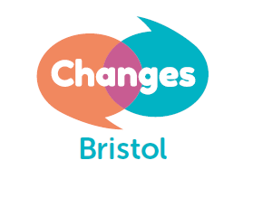
Changes Bristol Volunteer Application Form

Personal Information:
Name:
Address:
Postcode:
Date of Birth:
Phone:
Email address:

Position applied for:

Meeting Facilitator

TEll us about yourself:
Please tell us how you heard about us and why you would like to volunteer for Changes Bristol. Please include any relevant experience and personal qualities or skills you would bring to the role. You can continue on a separate sheet of paper if you need to.

AVAILABILITY:
Our support meetings happen on week days, in the daytime and evening, and face to face and online. Please tell us what is your availability for this role? Please note which days and times you would be able to volunteer or those which you definitely are not available.

What type of meeting would you like to volunteer for: Please delete as appropriate.

Online Groups Yes/No

Face to Face meetings Yes/No

your own experience:
Whilst it isn’t essential, we see it as a positive if you have your own experience of difficulties with your mental health. Do you have direct experience of mental distress?

References:
Please provide the names and full contact details of two people who are not related to you, who can comment on your suitability for this type of volunteer work. Applications submitted without the contact details of referees will not be processed.
Referee 1:
Name:
Address:
Email:
Phone:
Position held:

Referee 2:
Name:
Address:
Email:
Phone:
Position held:

How can we contact you?
We’d love to keep you updated with news about our vital services for mental wellbeing, ways to get involved and fundraising activities. Please tick the appropriate boxes to receive communications in this format.

Monthly E-newsletter

Email

Phone

Post

Changes Bristol will never sell your personal information to third parties, but we may need to share your details with suppliers who work on our behalf. See our Privacy Policy for more information on how we use and protect personal information. You can change your mind at any time by emailing info@changesbristol.org.uk

Submission:
Please submit this form for the attention of the Service Manager
Email: service@changesbristol.org.uk
Address: Changes Bristol
Barton Hill Settlement
41-43 Ducie Road
Bristol, BS5 0AX

Phone: 0117 941 1123

