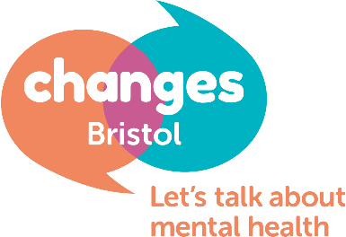
Volunteer Phone Befriender: Role Description
Details of the role: | Changes Bristol are looking for Volunteer Phone Befrienders to join our dedicated team so that people in Bristol continue to use the service we provide; they meet, share, connect and make steps towards better mental health.
Changes Bristol is running a telephone Befriending Service to support Members who are unable to access our online groups. Just like our peer support meetings, they’re for people suffering from mental distress, and more specifically those that can’t access the meetings whilst we’re having to provide them online. This Befriending Service is an important part of what we’re currently offering members and we need volunteers who can support others via telephone.

We have comprehensive training and offer ongoing supervision for any volunteers who will offer a safe, non-judgemental and empathetic listening ear for people to talk about their feelings and to help make changes in their lives for the better.

Being a Changes Volunteer is a responsible position - vulnerable adults rely on our service, therefore we need volunteers to be dependable and committed when taking on the role. Being a Befriender is an extremely rewarding and challenging role.
Deadline for applications | TBC
Induction training | By arrangement
Start date | negotiable
Tasks could include: | - Befrienders at Changes help people in the process of making sense of their experiences and expressing their feelings  - They offer a non-judgemental listening ear  - Befrienders support Members to make steps towards improving their lives through the use of SMART goals.  - As a Befriender, you may need to call on a wide range of skills and tools, including active listening, empathy, signposting, problem solving and risk assessing  - Listen, engage and empower – supporting members to find their own solutions to issues they’re facing or emotions they’re experiencing  - Be able to set and maintain clear boundaries and timekeeping  - Be comfortable consulting with a member of the Changes Staff Team regarding any concerns  - Initially all befriending will be done over the phone, but may expand to walk and talk sessions later in the year for those who would benefit from this service.
Person Specification | Good befriending requires:  - active listening  - the ability to set and maintain clear boundaries  - sensitivity to a wide variety of possible issues Members might be facing  If you feel you may possess these skills and would like to develop them further through the online training, engagement with our Members, reflective practice and supervision; please feel free to apply for the role.  Time required:  - Available for online training modules- dates to be confirmed.  - 1.5 hrs a week per person you support  - 3 hours for supervision and reflective practice 1x quarter  - We are a small charity and training new volunteers roughly costs us £200 so we ask that befrienders commit to volunteering for 9 months.
What we offer | Induction training for the role  Continuous support in form of supervision and reflective practice  Travel expenses reimbursed
 | We are looking for Volunteers who feel able to support at least 1 or more of our Members per week. The day and time will be by arrangement with the specific members.

If you are interested in this vacancy, please complete the application form using this role description and person specification. Please send your completed application to Alessandra and Matt on befriending@changesbristol.org.uk.
If you have any questions, or for an informal chat please contact Alessandra on 0117 941 1123 or Matt on 07566 789506.

