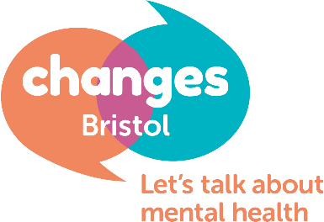
Meeting Facilitator: Role Description
Details of the role: | Changes Bristol are looking for Volunteer Facilitators to join our dedicated team so that people in Bristol continue to use the service we provide; they meet, share, connect and make steps towards better mental health.
Changes Bristol runs peer support meetings for people suffering from mental distress. Operating these support groups is the core of our activities and in order to run our meetings effectively we need volunteers to facilitate these meetings.

We have comprehensive training and supervision for new volunteers who will be responsible for creating a safe, non-judgemental and empathetic environment for people to talk about their feelings and to help make changes in their lives for the better.

Being a facilitator is a responsible position, where vulnerable adults rely on our service, therefore we need volunteers to be dependable and committed when taking on the role. Being a facilitator is an extremely rewarding and challenging role.
Deadline for applications | 13/03/2020
Induction training | Wednesday 8th, 15th & 22nd – attendance at all 3 is mandatory
Start date | negotiable
Tasks could include: | - Facilitators at Changes help people in the process of making sense of their experiences and expressing their feelings.  - They support members to make shared connections with others in the group.  - Facilitators support attendees to make steps towards improving their lives through the use of SMART goals.  - As a facilitator, you may need to call on a wide range of skills and tools, from problem-solving and decision making, to team management and communication.  - Listen, engage and include - even though, as facilitator, you're taking a neutral stance, you need to stay alert, listen actively, and remain interested and engaged. This sets a good example for other members, and also means you are always ready to intervene if needed  - Manage the time, summarise, reflect, set the ground rules, get things flowing  - Intervene with cross-talking and disruptions. Manage challenging situations and report safeguarding concerns.
Person Specification | Good facilitation skills require:  - careful observation  - active listening  - a good sense of timing  - sensitivity to overall group dynamics  - courage to allow the group to move into areas where the facilitator may not feel comfortable  If you feel you may possess these skills and would like to develop them further at the induction training and continuous reflective practice; please feel free to apply for the role.  Time required:  - Commitment to one group (3 hours) every week.  - 3 hours for supervision and reflective practice 1x quarter  - We are a small charity and training new volunteers roughly costs us £200 so we ask that facilitators commit to volunteering for 9 months.
What we offer | Induction training for the role  Continuous support in form of supervision and reflective practice  Travel expenses reimbursed
We are looking for facilitators for the following days/times:
Monday afternoon, Monday evening, Tuesday late morning (multiple), Wednesday afternoon, Thursday evening. Please note that this call-out is for these vacancies specifically.

If you are not available to volunteer during these days/times then we will not be able to invite you to training this time, but do get in touch for future opportunities.

If you are interested in this vacancy, please complete the application form using this role description and person specification. Please send your completed application to Tara on service@changesbristol.org.uk.
If you have any questions, or for an informal chat please contact Tara on 0117 941 1123

