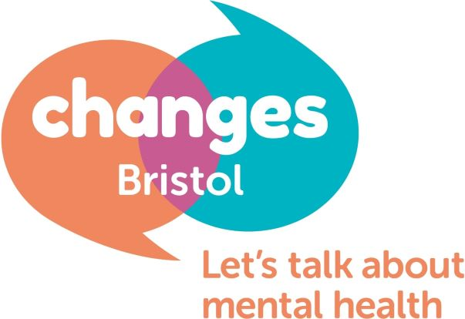

Dear Applicant,
Reference: Service Manager Vacancy
Please find enclosed an Application Form, Guidance notes, Job Description, Person Specification, and Equalities form for your attention.

This is a fantastic opportunity to be a part of a unique charity that is peer led and focussed on the wellbeing of its members and service users. We are looking to employ a person to cover 22.5 hours a week to be responsible for delivering the service Changes Bristol offers.

About Changes Bristol mental health charity

Changes Bristol is a mental health charity that provides a service to those suffering mental distress in greater Bristol. Our core service provides peer support meetings that run every week that are open access with no referral necessary, and where the support is there for as long as people need it.

We consider our service to be essential to the population of Bristol and wish to maintain, improve and expand our service in the coming years.

The recruitment process

This will involve completing and returning the enclosed Application form and Equalities form to be considered for the role. Please read the guidance notes before completing the application. These can be emailed to hannah@changesbristol.org.uk or sent in the post to the Changes Bristol office addressed to Hannah Smart.

After the closing date of 12th January at 5pm we will assess all the applications received and compile a shortlist of candidates. If you are chosen on the shortlist you will be invited for an interview at our offices. The interviews will take place in the 22nd of January. In some circumstances a second interview will be required. Interviews will last up to an hour.

We look forward to receiving your application in due course.

Kind regards

Jason Washbourne
Project Manager

